https://www.chamberofcommercementoneca.org
Mentone Chamber of Commerce MEMBERSHIP DRIVE 2026
TAX ID # 33-0970715
DEADLINE: Please MAIL in your membership dues/application by FEBRUARY 28, 2026 Or call for “pick up” Or bring them to the January 31st or the February 28th meeting.

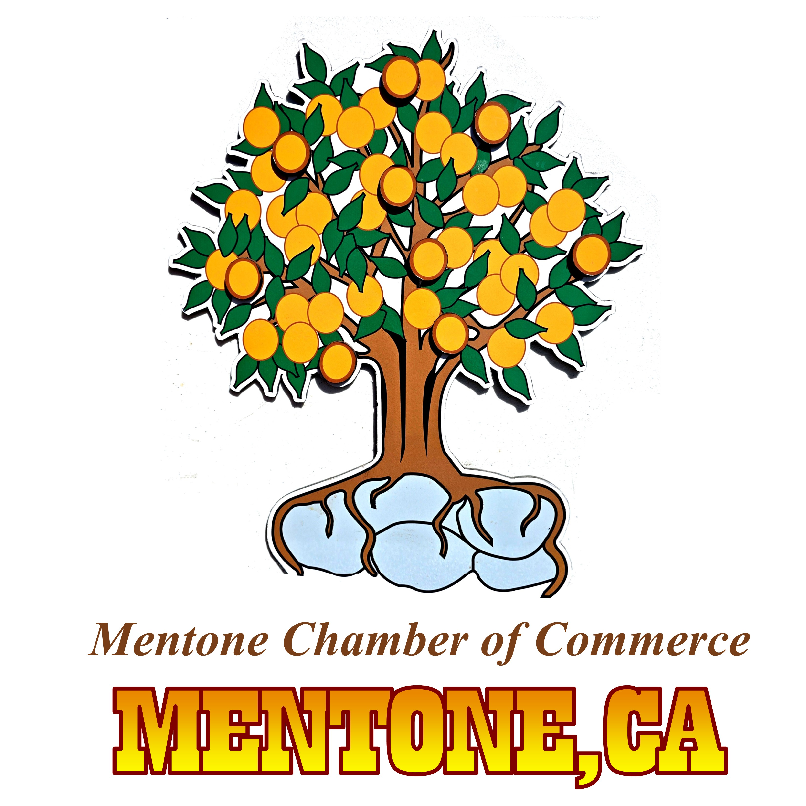

The Mentone Chamber of Commerce has sponsored the ongoing Mentone Days / Mentone Birthday Celebrations, the Western Casino Nights, and the annual Mentone CA International Film Festival! Most events are free or very affordable for our residents. Business Members can be involved and advertise at the events, donate opportunity prizes, or even host some type of event at their business.

When you become a chamber member, your business is listed on our Chamber Website.

The volunteers, who are all current Chamber Members, also are dedicated to the community. There are tasks that they take on that incur costs for the Chamber. Your dues will help with the following: Graffiti cleanup, Postage, Ink, Computer paper, Chamber phone bill, Banners, Gift certificates and other certificates or awards.

The Historical Murals have been a special addition to our community. They will need completion. (We had some talented volunteers in the past, may need to hire artists) These “Historical” murals welcome travelers to our business district. With a larger Sponsorship/Membership you can help!

The Mentone Chamber Membership dues are the lowest in the Inland Empire.
Most chambers charge a $300 - $400 yearly fee for a business with 1 -20 Employees.

Mentone Chamber Business Dues are only 50.00 each year. Individual 25.00

Currently, we have 20 businesses to renew for 2026, but our goal is to have 50 business members, at the least. The more members, the more exposure for Mentone and the increased ability to get grants for the community projects.

Please, return the completed application AND Check or money order in the envelope provided (Cash can be accepted in person) or use ZELLE: Chamber phone 909 362 7860 Return Application!
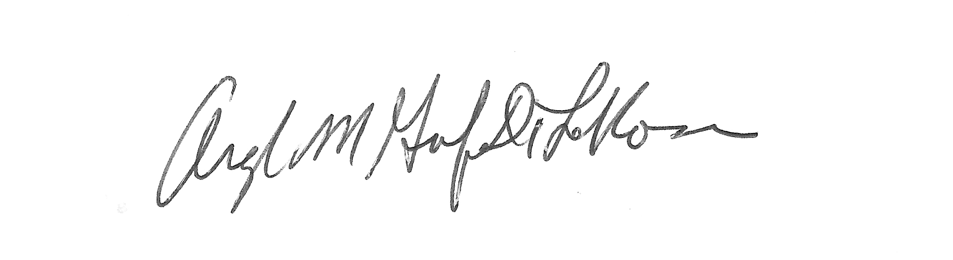
Presented by: Chair, Angela Grisafe- De La Rosa
Mentone Chamber of Commerce •PO BOX 246 •Mentone, CA 92359 •(909) 362 7860

