https://www.chamberofcommercementoneca.org
MENTONE CHAMBER OF COMMERCE MEMBERSHIP DRIVE AND RENEWALS 2026
DEADLINE
Please mail your membership app and dues by March 1, 2026
OR call the chamber for PICK UP
909 362 7860
TAX ID#33-0970715
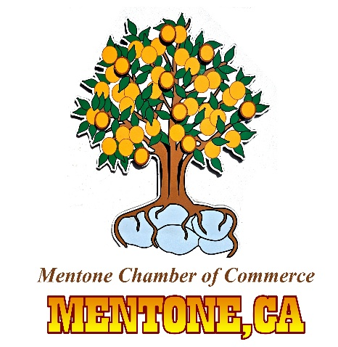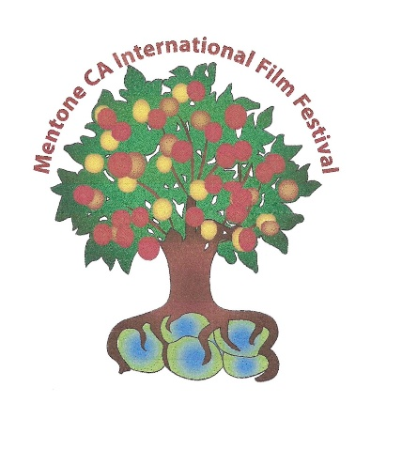

“The accomplishments that help the community and businesses”
MENTONE CHAMBER OF COMMERCE has sponsored the ANNUAL MENTONE DAYS, THE WESTERN CASINO NIGHT, AND THE MENTONE CA INTERNATIONAL FILM FESTIVAL.
VOLUNTEERS CLEAN UP THE BUSINESS DISTRICT BOARD MEMBERS ADVOCATE FOR THE COMMUNITY SAFETY AND IDENTITY.
When you become a chamber member your business or your individual name is displayed on the chamber website. The business location and photos are also on the website. The chamber webpage had 1900+ views In November 2024 during the festival.
Your dues help pay for supplies and events that the “non-paid” Officers and Board members provide. Tasks such as Graffiti cleanup, painting historical murals, and overall operating costs. Many of our resolute business members sponsor some of our events. A BUSINESS OR INDIVIDUAL can show on the application where they would like the sponsorship funds to be applied.
The chamber currently has twenty-four businesses to RENEW! The goal has always been to be at least 35-50 each year. Having your membership and dues on record and on the chamber website boosts the chamber image and makes us eligible for grants for the community projects.
Please reference the Deadline at the top of this page.
We can process ZELLE or VENMO payments 909 362 7860.
Receive checks at P O BOX 246-MENTONE CA-92359
Thank you, Angie Grisafe De La Rosa, Chair 2026

